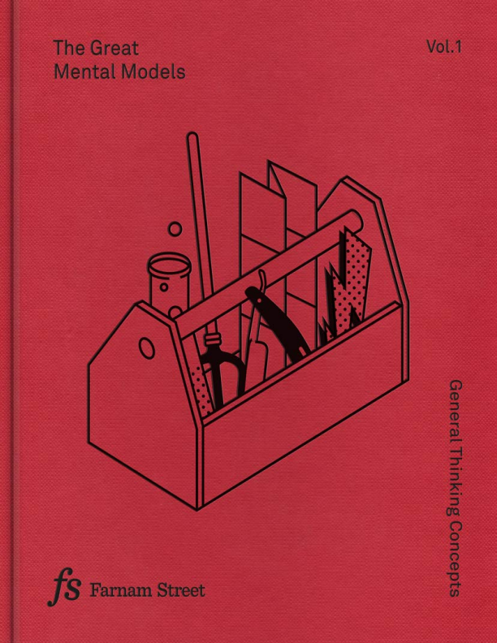

Farnam Street is devoted to helping you develop an understanding of how the world really works, make better decisions, and live a better life. We address such topics as mental models, decision-making, learning, reading, and the art of living.
In a world full of noise, Farnam Street is a place where you can step back and think about time-tested ideas while asking yourself questions that lead to meaningful understanding. We cover ideas from science and the humanities that will not only expand your intellectual horizons but also help you connect ideas, think in multidisciplinary ways, and explore meaning.
Headquartered in Ottawa, Canada, and run by Shane Parrish, we operate around the globe and have helped millions of people master the best of what other people have already figured out.
fs.blog

The quality of your thinking depends on the models that are in your head.
This is a statement we strongly believe in at Farnam Street. This conviction drives much of what we do.
When you learn to see the world as it is, and not as you want it to be, everything changes. The solution to any problem becomes more apparent when you can view it through more than one lens. You’ll be able to spot opportunities you couldn’t see before, avoid costly mistakes that may be holding you back, and begin to make meaningful progress in your life.
That’s the power of mental models. And that’s why we created the Great Mental Models project.
The Great Mental Models Project is a labor of love to help equalize opportunity in the world by making a high-quality, multidisciplinary, interconnected education free and available to everyone. That’s a big ambition. To get there, we’re starting with five reference books that cover core mental models from major disciplines: Biology, Physics, Chemistry, Economics, Systems and more. We have gathered these timeless individual ideas into a coherent whole.
Along with the books, we’re developing additional tools and resources to help readers more readily connect the models in their heads, so their use becomes second nature. By purchasing this book, you make it possible for us to continue our efforts and see this initiative through to completion. We’re grateful for your support. If you’d like to learn more about the Great Mental Models project, please visit FS.blog/tgmm
Published by Latticework Publishing Inc. under license from Farnam Street Media Inc.
PO BOX 14037, RPO Glebe, Ottawa, ON K1S 3T2
Copyright: Farnam Street Media Inc.
Creative Direction by Morgwn Rimel
Designed and typeset by FLOK, Berlin
Illustrations by Marcia Mihotich, London
Printed in Latvia by Livonia Print
Ebook by Bright Wing Books
All rights reserved.
A portion of this work has appeared online at fs.blog.
While every effort has been made to contact copyright holders, if we have overlooked anything please let us know. This book wouldn’t be possible without the insights of others. The goal of FS is to master the best of what other people have figured out. True to this mission, everything in here began with someone else.
Any reproduction of this book requires written permission. www.fs.blog
ISBN: 978-1-9994490-0-1

Contents
Preface
Acquiring Wisdom
General Thinking Concepts: The Map is not the Territory Circle of Competence
First Principles Thinking Thought Experiment
Second-Order Thinking
Probabilistic Thinking
Inversion
Occam’s Razor
Hanlon’s Razor
Supporting Ideas:
Falsifiability
Necessity and Sufficiency
Causation vs. Correlation Acknowledgements
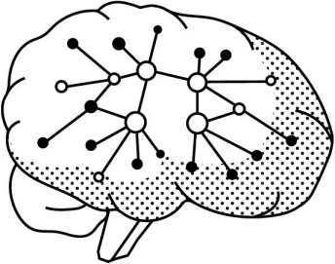_
The key to better understanding the world is to build a latticework of mental models.
The People Who Appear in the Preface
Munger, Charlie (Charles),
1924 - American investor, businessman and philanthropist. Vice-Chairman of Berkshire Hathaway. Avid proponent that elementary, worldly wisdom and high ethical standards are required in business.
Buffett, Warren,
1930 - American investor, businessman and philanthropist. Chairman and CEO of Berkshire Hathaway. Often referred to as “the Oracle of Omaha”, he is considered one of the most successful investors in the world.
Preface
Education doesn’t prepare you for the real world. At least, it didn’t prepare me. I was two weeks into my job at an intelligence agency on September 11, 2001 when the world suddenly changed. The job I had been hired to do was no longer the one that was needed. I had a computer science degree; I came from a world of 1s and 0s, not people, families, and interpersonal dynamics. I was thrust into a series of promotions for which I had received no guidance, that came with responsibilities I had no idea how to navigate. Now I found that my decisions affected not only my employees but their families. Not only my country, but other countries. The only problem? I had no idea how to make decisions. I only knew I had an obligation to make the best decisions I could.
To improve my ability to make decisions, I looked around and found some mentors. I watched them carefully and learned from them. I read everything I could about making decisions. I even took some time off work to go back to school and earn my MBA, hoping that I would finally learn how to make better decisions, as if that was some end state rather than a constantly evolving journey.
My belief that the MBA program was a good use of my time was eroded fairly quickly. When I showed up to write an exam only to find out it was an open book test, I realized my expectations were entirely wrong and in need of updating. Was I in a master’s program or grade school? Some days, I couldn’t tell. And yet that is where everything changed for me.
I realized that I couldn’t fail as long as I knew where the answers were in the books I could bring to the exams. This was actually quite liberating. I stopped putting effort into my assignments and started learning about someone who was casually mentioned in class. That person was Charlie Munger. I went from theoretical examples that were completely
divorced from the real world, to the wisdom behind the achievements of one of the most successful businessmen of all time. Munger, who you will come to know in these volumes, is the billionaire business partner of Warren Buffett at Berkshire Hathaway. He’s easy to like: intelligent, witty, and irreverent. Finding Munger opened the door to unexpected intellectual pleasure. I felt like I had finally found knowledge that was useful because it was gained from someone’s real effort to better understand how the world works. It was so much more satisfying to learn from someone who had tried to put many theories into practice and was willing to share his results. The fact that Munger was so professionally successful made it all the more compelling.
Munger has a way of thinking through problems using what he calls a broad latticework of mental models. These are chunks of knowledge from different disciplines that can be simplified and applied to better understand the world. The way he describes it, they help identify what information is relevant in any given situation, and the most reasonable parameters to work in. His track record shows that this doesn’t just make sense in theory but is devastatingly useful in practice. I started writing about my learnings, the result being the website fs.blog. The last eight years of my life have been devoted to identifying and learning the mental models that have the greatest positive impact, and trying to understand how we think, how we update, how we learn, and how we can make better decisions.
I joke with my kids that if you want to suck up someone’s brain, you should simply read a book. All the great wisdom of humanity is written down somewhere. When we were talking about mental models one day the kids asked if we had the mental models book. This made me pause, and I was struck with the realization that such a book didn’t exist. I didn’t have something I could share with my kids, and that was a problem. A very solvable problem.
This book, and the volumes which will follow, are the books I wish
had existed years ago when I started learning about mental models. These are my homage to the idea that we can benefit from understanding how the world works and applying that understanding to keep us out of trouble.
The ideas in these volumes are not my own, nor do I deserve any credit for them. They come from the likes of Charlie Munger, Nassim Taleb, Charles Darwin, Peter Kaufman, Peter Bevelin, Richard Feynman, Albert Einstein, and so many others. As the Roman poet Publius Terentius wrote: “Nothing has yet been said that’s not been said before.” I’ve only curated, edited, and shaped the work of others before me.
The timeless, broad ideas in these volumes are for my children and their children and their children’s children. In creating them, I hope to allow others to approach problems with clarity and confidence, helping to make their journey through life more successful and rewarding.
« You only think you know, as a matter of fact. And most of your actions are based on incomplete knowledge and you really don’t know what it is all about, or what the purpose of the world is, or know a great deal of other things. It is possible to live and not know. »
Richard Feynman ¹
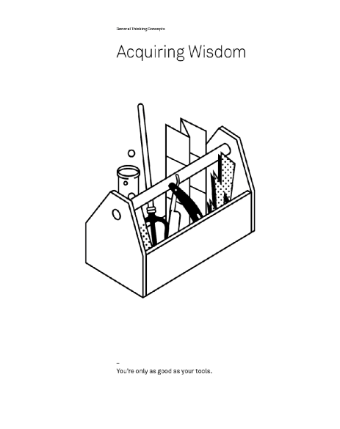
I believe in the discipline of mastering the best of what other people have figured out. Charlie Munger¹
The People Who Appear in this Chapter
Galilei, Galileo.
1564-1642 - Italian polymath. He made significant contributions to astronomy, physics, and engineering and is thought of by many as the father of modern science. His brilliance continues to inspire and references to him can be found in many places, including songs by Queen and the Indigo Girls.
Introduction: Acquiring Wisdom
In life and business, the person with the fewest blind spots wins. Removing blind spots means we see, interact with, and move closer to understanding reality. We think better. And thinking better is about finding simple processes that help us work through problems from multiple dimensions and perspectives, allowing us to better choose solutions that fit what matters to us. The skill for finding the right solutions for the right problems is one form of wisdom.
This book is about the pursuit of that wisdom, the pursuit of uncovering how things work, the pursuit of going to bed smarter than when we woke up. It is a book about getting out of our own way so we can understand how the world really is. Decisions based on improved understanding will be better than ones based on ignorance. While we can’t predict which problems will inevitably crop up in life, we can learn time tested ideas that help us prepare for whatever the world throws at us.
Perhaps more importantly, this book is about avoiding problems. This often comes down to understanding a problem accurately and seeing the secondary and subsequent consequences of any proposed action. The author and explorer of mental models, Peter Bevelin, put it best: “I don’t want to be a great problem solver. I want to avoid problems—prevent them
2
from happening and doing it right from the beginning.” How can we do things right from the beginning?
We must understand how the world works and adjust our behavior accordingly. Contrary to what we’re led to believe, thinking better isn’t about being a genius. It is about the processes we use to uncover reality and the choices we make once we do.
How this book can help you
This is the first of a series of volumes aimed at defining and exploring the
Great Mental Models—those that have the broadest utility across our lives. Mental models describe the way the world works. They shape how we think, how we understand, and how we form beliefs. Largely subconscious, mental models operate below the surface. We’re not generally aware of them and yet they’re the reason when we look at a problem we consider some factors relevant and others irrelevant. They are how we infer causality, match patterns, and draw analogies. They are how we think and reason.
A mental model is simply a representation of how something works. We cannot keep all of the details of the world in our brains, so we use models to simplify the complex into understandable and organizable chunks. Whether we realize it or not, we then use these models every day to think, decide, and understand our world. While there are millions of mental models, some true and some false, these volumes will focus on the ones with the greatest utility—the all-star team of mental models.
Volume One presents the first nine models, general thinking concepts. Although these models are hiding in plain sight, they are useful tools that you were likely never directly taught. Put to proper use, they will improve your understanding of the world we live in and improve your ability to look at a situation through different lenses, each of which reveals a different layer. They can be used in a wide variety of situations and are essential to making rational decisions, even when there is no clear path. Collectively they will allow you to walk around any problem in a three dimensional way.
Our approach to the Great Mental Models rests on the idea that the fundamentals of knowledge are available to everyone. There is no discipline that is off limits—the core ideas from all fields of study contain principles that reveal how the universe works, and are therefore essential to navigating it. Our models come from fundamental disciplines that most of us have never studied, but no prior knowledge is required—only a sharp mind with
a desire to learn.
Why mental models?
There is no system that can prepare us for all risks. Factors of chance introduce a level of complexity that is not entirely predictable. But being able to draw on a repertoire of mental models can help us minimize risk by understanding the forces that are at play. Likely consequences don’t have to be a mystery.
Not having the ability to shift perspective by applying knowledge from multiple disciplines makes us vulnerable. Mistakes can become catastrophes whose effects keep compounding, creating stress and limiting our choices. Multidisciplinary thinking, learning these mental models and applying them across our lives, creates less stress and more freedom. The more we can draw on the diverse knowledge contained in these models, the more solutions will present themselves.
Understanding reality
Understanding reality is a vague phrase, one you’ve already encountered as you’ve read this book. Of course we want to understand reality, but how? And why is it important?
In order to see a problem for what it is, we must first break it down into its substantive parts so the interconnections can reveal themselves. This bottom-up perspective allows us to expose what we believe to be the causal relationships and how they will govern the situation both now and in the future. Being able to accurately describe the full scope of a situation is the first step to understanding it.
Using the lenses of our mental models helps us illuminate these interconnections. The more lenses used on a given problem, the more of reality reveals itself. The more of reality we see, the more we understand. The more we understand, the more we know what to do.
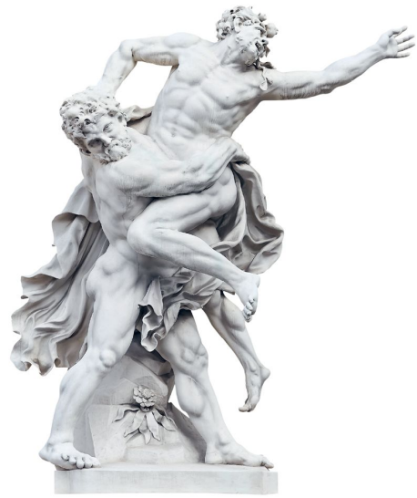
_
To defeat Antaeus, Heracles separated him from the source of his power.
Simple and well-defined problems won’t need many lenses, as the variables that matter are known. So too are the interactions between them. In such cases we generally know what to do to get the intended results with the fewest side effects possible. When problems are more complicated, however, the value of having a brain full of lenses becomes readily apparent.
That’s not to say all lenses (or models) apply to all problems. They don’t. And it’s not to say that having more lenses (or models) will be an advantage in all problems. It won’t. This is why learning and applying the Great Mental Models is a process that takes some work. But the truth is, most problems are multidimensional, and thus having more lenses often offers significant help with the problems we are facing.
Keeping your feet on the ground
In Greek mythology, Antaeus was the human-giant son of Poseidon, god of the sea, and Gaia, Mother Earth. Antaeus had a strange habit. He would challenge all those who passed through his country to a wrestling match. Greek wrestling isn’t much different from what we think of today when we think of wrestling. The goal is to force the opponent to the ground. Antaeus always won and his opponents’ skulls were used to build a temple to his father. While Antaeus was undefeated and nearly undefeatable, there was a catch to his invulnerability. His epic strength depended on constant contact with the earth. When he lost touch with earth, he lost all of his strength.
On the way to the Garden of the Hesperides, Heracles was to fight Antaeus as one of his 12 labors. After a few rounds in which Heracles flung the giant to the ground only to watch him revive, he realized he could not win by using traditional wrestling techniques. Instead, Heracles fought to lift him off the ground. Away from contact with his mother, Antaeus lost his
strength and Heracles crushed him.
3 , 4
When understanding is separated from reality, we lose our powers.
Understanding must constantly be tested against reality and updated accordingly. This isn’t a box we can tick, a task with a definite beginning and end, but a continuous process.
You all know the person who has all the answers on how to improve your organization, or the friend who has the cure to world hunger. While pontificating with friends over a bottle of wine at dinner is fun, it won’t help you improve. The only way you’ll know the extent to which you understand reality is to put your ideas and understanding into action. If you don’t test your ideas against the real world—keep contact with the earth— how can you be sure you understand?
Getting in our own way
The biggest barrier to learning from contact with reality is ourselves. It’s hard to understand a system that we are part of because we have blind spots, where we can’t see what we aren’t looking for, and don’t notice what we don’t notice.
« There are these two young fish swimming along and they happen to meet an older fish swimming the other way, who nods at them and says “Morning, boys. How’s the water?” And the two young fish swim on for a bit, and then eventually one of them looks over at the other and goes “What the hell is water?” »
David Foster Wallace 5
Our failures to update from interacting with reality spring primarily from
three things: not having the right perspective or vantage point, ego-induced denial, and distance from the consequences of our decisions. As we will learn in greater detail throughout the volumes on mental models, these can all get in the way. They make it easier to keep our existing and flawed beliefs than to update them accordingly. Let’s briefly flesh these out:
The first flaw is perspective. We have a hard time seeing any system that we are in. Galileo had a great analogy to describe the limits of our default perspective. Imagine you are on a ship that has reached constant velocity (meaning without a change in speed or direction). You are below decks and there are no portholes. You drop a ball from your raised hand to the floor. To you, it looks as if the ball is dropping straight down, thereby confirming gravity is at work.
Now imagine you are a fish (with special x-ray vision) and you are watching this ship go past. You see the scientist inside, dropping a ball. You register the vertical change in the position of the ball. But you are also able to see a horizontal change. As the ball was pulled down by gravity it also shifted its position east by about 20 feet. The ship moved through the water and therefore so did the ball. The scientist on board, with no external point of reference, was not able to perceive this horizontal shift.
This analogy shows us the limits of our perception. We must be open to other perspectives if we truly want to understand the results of our actions. Despite feeling that we’ve got all the information, if we’re on the ship, the fish in the ocean has more he can share.
The second flaw is ego. Many of us tend to have too much invested in our opinions of ourselves to see the world’s feedback—the feedback we need to update our beliefs about reality. This creates a profound ignorance that keeps us banging our head against the wall over and over again. Our inability to learn from the world because of our ego happens for many reasons, but two are worth mentioning here. First, we’re so afraid about
what others will say about us that we fail to put our ideas out there and subject them to criticism. This way we can always be right. Second, if we do put our ideas out there and they are criticized, our ego steps in to protect us. We become invested in defending instead of upgrading our ideas.
The third flaw is distance. The further we are from the results of our decisions, the easier it is to keep our current views rather than update them. When you put your hand on a hot stove, you quickly learn the natural consequence. You pay the price for your mistakes. Since you are a pain avoiding creature, you update your view. Before you touch another stove, you check to see if it’s hot. But you don’t just learn a micro lesson that applies in one situation. Instead, you draw a general abstraction, one that tells you to check before touching anything that could potentially be hot.
Organizations over a certain size often remove us from the direct consequences of our decisions. When we make decisions that other people carry out, we are one or more levels removed and may not immediately be able to update our understanding. We come a little off the ground, if you will. The further we are from the feedback of the decisions, the easier it is to convince ourselves that we are right and avoid the challenge, the pain, of updating our views.
Admitting that we’re wrong is tough. It’s easier to fool ourselves that we’re right at a high level than at the micro level, because at the micro level we see and feel the immediate consequences. When we touch that hot stove, the feedback is powerful and instantaneous. At a high or macro level we are removed from the immediacy of the situation, and our ego steps in to create a narrative that suits what we want to believe, instead of what really happened.
These flaws are the main reasons we keep repeating the same mistakes, and why we need to keep our feet on the ground as much as we can. As Confucius said, “A man who has committed a mistake and doesn’t correct it, is committing another mistake.”
The majority of the time, we don’t even perceive what conflicts with our beliefs. It’s much easier to go on thinking what we’ve already been thinking than go through the pain of updating our existing, false beliefs. When it comes to seeing what is—that is, understanding reality—we can follow Charles Darwin’s advice to notice things “which easily escape attention,” and ask why things happened.
We also tend to undervalue the elementary ideas and overvalue the complicated ones. Most of us get jobs based on some form of specialized knowledge, so this makes sense. We don’t think we have much value if we know the things everyone else does, so we focus our effort on developing unique expertise to set ourselves apart. The problem is then that we reject the simple to make sure what we offer can’t be contributed by someone else. But simple ideas are of great value because they can help us prevent complex problems.
In identifying the Great Mental Models we have looked for elementary principles, the ideas from multiple disciplines that form a time tested foundation. It may seem counterintuitive, to work on developing knowledge that is available to everyone, but the universe works in the same way no matter where you are in it. What you need is to understand the principles, so that when the details change you are still able to identify what is really going on. This is part of what makes the Great Mental Models so valuable—understanding the principles, you can easily change tactics to apply the ones you need.
« Most geniuses—especially those who lead others— prosper not by deconstructing intricate complexities but by exploiting unrecognized simplicities. » Andy Benoit ⁶
These elementary ideas, so often overlooked, are from multiple disciplines: biology, physics, chemistry, and more. These help us understand the interconnections of the world, and see it for how it really is. This understanding allows us to develop causal relationships, which allow us to match patterns, which allow us to draw analogies. All of this so we can navigate reality with more clarity and comprehension of the real dynamics involved.
Understanding is not enough
However, understanding reality is not everything. The pursuit of understanding fuels meaning and adaptation, but this understanding, by itself, is not enough.
Understanding only becomes useful when we adjust our behavior and actions accordingly. The Great Models are not just theory. They are actionable insights that can be used to effect positive change in your life. What good is it to know that you constantly interrupt people if you fail to adjust your behavior in light of this? In fact, if you know and don’t change your behavior it often has a negative effect. People around you will tell themselves the simplest story that makes sense to them given what they see: that you just don’t care. Worse still, because you understand that you interrupt people, you’re surprised when you get the same results over and over. Why? You’ve failed to reflect on your new understanding and adjust your behavior.
In the real world you will either understand and adapt to find success or you will fail
Now you can see how we make suboptimal decisions and repeat mistakes. We are afraid to learn and admit when we don’t know enough. This is the mindset that leads to poor decisions. They are a source of stress and anxiety, and consume massive amounts of time. Not when we’re making them—no, when we’re making them they seem natural because they align with our
view of how we want things to work. We get tripped up when the world doesn’t work the way we want it to or when we fail to see what is. Rather than update our views, we double down our effort, accelerating our frustrations and anxiety. It’s only weeks or months later, when we’re spending massive amounts of time fixing our mistakes, that they start to increase their burden on us. Then we wonder why we have no time for family and friends and why we’re so consumed by things outside of our control.
We are passive, thinking these things just happened to us and not that we did something to cause them. This passivity means that we rarely reflect on our decisions and the outcomes. Without reflection we cannot learn. Without learning we are doomed to repeat mistakes, become frustrated when the world doesn’t work the way we want it to, and wonder why we are so busy. The cycle goes on.
But we are not passive participants in our decisions. The world does not act on us as much as it reveals itself to us and we respond. Ego gets in the way, locking reality behind a door that it controls with a gating mechanism. Only through persistence in the face of having it slammed on us over and over can we begin to see the light on the other side.
Ego, of course, is more than the enemy. It’s also our friend. If we had a perfect view of the world and made decisions rationally, we would never attempt to do the amazing things that make us human. Ego propels us. Why, without ego, would we even attempt to travel to Mars? After all, it’s never been done before. We’d never start a business because most of them fail. We need to learn to understand when ego serves us and when it hinders us. Wrapping ego up in outcomes instead of in ourselves makes it easier to update our views.
We optimize for short-term ego protection over long-term happiness. Increasingly, our understanding of things becomes black and white rather than shades of grey. When things happen in accord with our view of the
world we naturally think they are good for us and others. When they conflict with our views, they are wrong and bad. But the world is smarter than we are and it will teach us all we need to know if we’re open to its feedback—if we keep our feet on the ground.
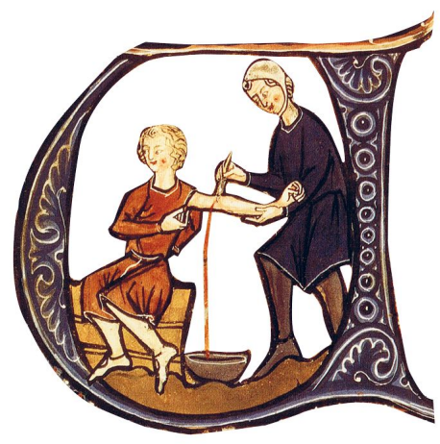
_
Despite having consistently bad results for patients, bloodletting was practiced for over 2,000 years.
Mental models and how to use them
Perhaps an example will help illustrate the mental models approach. Think of gravity, something we learned about as kids and perhaps studied more
formally in university as adults. We each have a mental model about gravity, whether we know it or not. And that model helps us to understand how gravity works. Of course we don’t need to know all of the details, but we know what’s important. We know, for instance, that if we drop a pen it will fall to the floor. If we see a pen on the floor we come to a probabilistic conclusion that gravity played a role.
This model plays a fundamental role in our lives. It explains the movement of the Earth around the sun. It informs the design of bridges and airplanes. It’s one of the models we use to evaluate the safety of leaning on a guard rail or repairing a roof. But we also apply our understanding of gravity in other, less obvious ways. We use the model as a metaphor to explain the influence of strong personalities, as when we say, “He was pulled into her orbit.” This is a reference to our basic understanding of the role of mass in gravity—the more there is the stronger the pull. It also informs some classic sales techniques. Gravity diminishes with distance, and so too does your propensity to make an impulse buy. Good salespeople know that the more distance you get, in time or geography, between yourself and the object of desire, the less likely you are to buy. Salespeople try to keep the pressure on to get you to buy right away.
Gravity has been around since before humans, so we can consider it to be time-tested, reliable, and representing reality. And yet, can you explain gravity with a ton of detail? I highly doubt it. And you don’t need to for the model to be useful to you. Our understanding of gravity, in other words, our mental model, lets us anticipate what will happen and also helps us explain what has happened. We don’t need to be able to describe the physics in detail for the model to be useful.
However, not every model is as reliable as gravity, and all models are flawed in some way. Some are reliable in some situations but useless in others. Some are too limited in their scope to be of much use. Others are unreliable because they haven’t been tested and challenged, and yet others
are just plain wrong. In every situation, we need to figure out which models are reliable and useful. We must also discard or update the unreliable ones, because unreliable or flawed models come with a cost.
For a long time people believed that bloodletting cured many different illnesses. This mistaken belief actually led doctors to contribute to the deaths of many of their patients. When we use flawed models we are more likely to misunderstand the situation, the variables that matter, and the cause and effect relationships between them. Because of such misunderstandings we often take suboptimal actions, like draining so much blood out of patients that they die from it.
Better models mean better thinking. The degree to which our models accurately explain reality is the degree to which they improve our thinking. Understanding reality is the name of the game. Understanding not only helps us decide which actions to take but helps us remove or avoid actions that have a big downside that we would otherwise not be aware of. Not only do we understand the immediate problem with more accuracy, but we can begin to see the second-, third-, and higher-order consequences. This understanding helps us eliminate avoidable errors. Sometimes making good decisions boils down to avoiding bad ones.
Flawed models, regardless of intentions, cause harm when they are put to use. When it comes to applying mental models we tend to run into trouble either when our model of reality is wrong, that is, it doesn’t survive real world experience, or when our model is right and we apply it to a situation where it doesn’t belong.
Models that don’t hold up to reality cause massive mistakes. Consider that the model of bloodletting as a cure for disease caused unnecessary death because it weakened patients when they needed all their strength to fight their illnesses. It hung around for such a long time because it was part of a package of flawed models, such as those explaining the causes of sickness and how the human body worked, that made it difficult
to determine exactly where it didn’t fit with reality.
We compound the problem of flawed models when we fail to update our models when evidence indicates they are wrong. Only by repeated testing of our models against reality and being open to feedback can we update our understanding of the world and change our thinking. We need to look at the results of applying the model over the largest sample size possible to be able to refine it so that it aligns with how the world actually works.
— Sidebar: What Can the Three Buckets of Knowledge Teach Us About History?
The power of acquiring new models
The quality of our thinking is largely influenced by the mental models in our heads. While we want accurate models, we also want a wide variety of models to uncover what’s really happening. The key here is variety. Most of us study something specific and don’t get exposure to the big ideas of other disciplines. We don’t develop the multidisciplinary mindset that we need to accurately see a problem. And because we don’t have the right models to understand the situation, we overuse the models we do have and use them even when they don’t belong.
You’ve likely experienced this first hand. An engineer will often think in terms of systems by default. A psychologist will think in terms of incentives. A business person might think in terms of opportunity cost and risk-reward. Through their disciplines, each of these people sees part of the situation, the part of the world that makes sense to them. None of them, however, see the entire situation unless they are thinking in a multidisciplinary way. In short, they have blind spots. Big blind spots. And they’re not aware of their blind spots. There is an old adage that encapsulates this: “To the man with only a hammer, everything starts looking like a nail.” Not every problem is a nail. The world is full of
complications and interconnections that can only be explained through understanding of multiple models.
What Can the Three Buckets of Knowledge Teach Us About History?
“Every statistician knows that a large, relevant sample size is their best friend. What are the three largest, most relevant sample sizes for identifying universal principles? Bucket number one is inorganic systems, which are 13.7 billion years in size. It’s all the laws of math and physics, the entire physical universe. Bucket number two is organic systems, 3.5 billion years of biology on Earth. And bucket number three is human history, you can pick your own number, I picked 20,000 years of recorded human behavior. Those are the three largest sample sizes we can access and the most relevant.” —Peter Kaufman
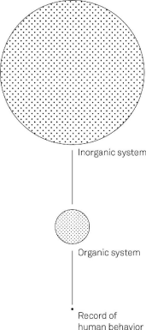
The larger and more relevant the sample size, the more reliable the model based on it is. But the key to sample sizes is to look for them not just over space, but over time. You need to reach back into the past as far as you can to contribute to your sample. We have a tendency to think that how the world is, is how it always was. And so we get caught up validating our assumptions from what we find in the here and now. But the continents used to be pushed against each other, dinosaurs walked the planet for millions of years, and we are not the only hominid to evolve. Looking to the past can provide essential context for understanding where we are now.
Removing blind spots means thinking through the problem using different lenses or models. When we do this the blind spots slowly go away and we gain an understanding of the problem.
We’re much like the blind men in the classic parable of the elephant, going through life trying to explain everything through one limited lens. Too often that lens is driven by our particular field, be it economics, engineering, physics, mathematics, biology, chemistry, or something else entirely. Each of these disciplines holds some truth and yet none of them contain the whole truth.
Here’s another way to look at it: think of a forest. When a botanist looks at it they may focus on the ecosystem, an environmentalist sees the impact of climate change, a forestry engineer the state of the tree growth, a business person the value of the land. None are wrong, but neither are any of them able to describe the full scope of the forest. Sharing knowledge, or learning the basics of the other disciplines, would lead to a more well rounded understanding that would allow for better initial decisions about managing the forest.
Relying on only a few models is like having a 400-horsepower brain that’s only generating 50 horsepower of output. To increase your mental efficiency and reach your 400-horsepower potential, you need to use a latticework of mental models. Exactly the same sort of pattern that graces backyards everywhere, a lattice is a series of points that connect to and reinforce each other. The Great Models can be understood in the same way —models influence and interact with each other to create a structure that can be used to evaluate and understand ideas.
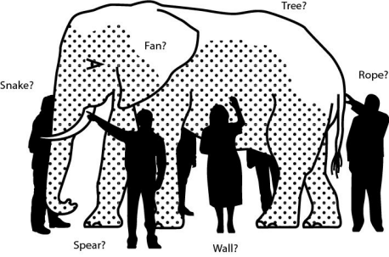
_
A group of blind people approach a strange animal, called an elephant. None of them are aware of its shape and form. So they decide to understand it by touch. The first person, whose hand touches the trunk, says, “This creature is like a thick snake.” For the second person, whose hand finds an ear, it seems like a type of fan. The third person, whose hand is on a leg, says the elephant is a pillar like a tree-trunk. The fourth blind man who places his hand on the side says, “An elephant is a wall.” The fifth, who feels its tail, describes it as a rope. The last touches its tusk, and states the elephant is something that is hard and smooth, like a spear.
In a famous speech in the 1990s, Charlie Munger summed up this approach to practical wisdom: “Well, the first rule is that you can’t really know anything if you just remember isolated facts and try and bang ‘em back. If the facts don’t hang together on a latticework of theory, you don’t
have them in a usable form. You’ve got to have models in your head. And you’ve got to array your experience both vicarious and direct on this latticework of models. You may have noticed students who just try to remember and pound back what is remembered. Well, they fail in school and in life. You’ve got to hang experience on a latticework of models in
your head.”
8
« The chief enemy of good decisions is a lack of sufficient perspectives on a problem. »
Alain de Botton
9
Expanding your latticework of mental models
A latticework is an excellent way to conceptualize mental models, because it demonstrates the reality and value of interconnecting knowledge. The world does not isolate itself into discrete disciplines. We only break it down that way because it makes it easier to study it. But once we learn something, we need to put it back into the complex system in which it occurs. We need to see where it connects to other bits of knowledge, to build our understanding of the whole. This is the value of putting the knowledge contained in mental models into a latticework.
It reduces the blind spots that limit our view of not only the immediate problem, but the second and subsequent order effects of our potential solutions. Without a latticework of the Great Models our decisions become harder, slower, and less creative. But by using a mental models approach, we can complement our specializations by being curious about how the rest of the world works. A quick glance at the Nobel Prize winners list show that many of them, obviously extreme specialists in something, had multidisciplinary interests that supported their achievements.
To help you build your latticework of mental models, this book, and
the books that follow, attempt to arm you with the big models from multiple disciplines. We’ll take a look at biology, physics, chemistry, economics, and even psychology. We don’t need to master all the details from these disciplines, just the fundamentals.
To quote Charlie Munger, “80 or 90 important models will carry about 90 percent of the freight in making you a worldly-wise person. And,
10
of those, only a mere handful really carry very heavy freight.”
These books attempt to collect and make accessible organized common sense—the 80 to 90 mental models you need to get started. To help you understand the models, we will relate them to historical examples and stories. Our website fs.blog will have even more practical examples.
The more high-quality mental models you have in your mental toolbox, the more likely you will have the ones needed to understand the problem. And understanding is everything. The better you understand, the better the potential actions you can take. The better the potential actions, the fewer problems you’ll encounter down the road. Better models make better decisions.
«I think it is undeniably true that the human brain must work in models. The trick is to have your brain work better than the other person’s brain because it understands the most fundamental models: ones that will do most work per unit. If you get into the mental habit of relating what you’re reading to the basic structure of the underlying ideas being demonstrated, you gradually accumulate some wisdom.»
Charlie Munger
11
It takes time, but the benefits are enormous
What successful people do is file away a massive, but finite, amount of fundamental, established, essentially unchanging knowledge that can be used in evaluating the infinite number of unique scenarios which show up in the real world.
It’s not just knowing the mental models that is important. First you must learn them, but then you must use them. Each decision presents an opportunity to comb through your repertoire and try one out, so you can also learn how to use them. This will slow you down at first, and you won’t always choose the right models, but you will get better and more efficient at using mental models as time progresses.
We need to work hard at synthesizing across the borders of our knowledge, and most importantly, synthesizing all of the ideas we learn with reality itself. No model contains the entire truth, whatever that may be. What good are math and biology and psychology unless we know how they fit together in reality itself, and how to use them to make our lives better? It would be like dying of hunger because we don’t know how to combine and cook any of the foods in our pantry.
«Disciplines, like nations, are a necessary evil that enable human beings of bounded rationality to simplify their goals and reduce their choices to
calculable limits. But parochialism is everywhere, and the world badly needs international and interdisciplinary travelers to carry new knowledge from one enclave to another.»
Herbert Simon ¹²
You won’t always get it right. Sometimes the model, or models, you choose to use won’t be the best ones for that situation. That’s okay. The more you use them, the more you will be able to build the knowledge of indicators that can trigger the use of the most appropriate model. Using and failing, as long as you acknowledge, reflect, and learn from it, is also how you build your repertoire.
You need to be deliberate about choosing the models you will use in a situation. As you use them, a great practice is to record and reflect. That way you can get better at both choosing models and applying them. Take the time to notice how you applied them, what the process was like, and what the results were. Over time you will develop your knowledge of which situations are best tackled through which models. Don’t give up on a model if it doesn’t help you right away. Learn more about it, and try to figure out exactly why it didn’t work. It may be that you have to improve your understanding. Or there were aspects of the situation that you did not consider. Or that your focus was on the wrong variable. So keep a journal. Write your experiences down. When you identify a model at work in the world, write that down too. Then you can explore the applications you’ve observed, and start being more in control of the models you use every day. For instance, instead of falling victim to confirmation bias, you will be able to step back and see it at work in yourself and others. Once you get practice, you will start to naturally apply models as you go through your life, from reading the news to contemplating a career move.
As we have seen, we can run into problems when we apply models to situations in which they don’t fit. If a model works, we must invest the time and energy into understanding why it worked so we know when to use it again. At the beginning the process is more important than the outcome. As you use the models, stay open to the feedback loops. Reflect and learn. You will get better. It will become easier. Results will become more profoundly useful, more broadly applicable, and more memorable. While
this book isn’t intended to be a book specifically about making better decisions, it will help you make better decisions. Mental models are not an excuse to create a lengthy decision process but rather to help you move away from seeing things the way you think they should be to the way they are. Uncovering this knowledge will naturally help your decision-making. Right now you are only touching one part of the elephant, so you are making all decisions based on your understanding that it’s a wall or a rope, not an animal. As soon as you begin to take in the knowledge that other people have of the world, like learning the perspectives others have of the elephant, you will start having more success because your decisions will be aligned with how the world really is.
When you start to understand the world better, when the whys seem less mysterious, you gain confidence in how you navigate it. The successes will accrue. And more success means more time, less stress, and ultimately a more meaningful life.
Time to dive in.
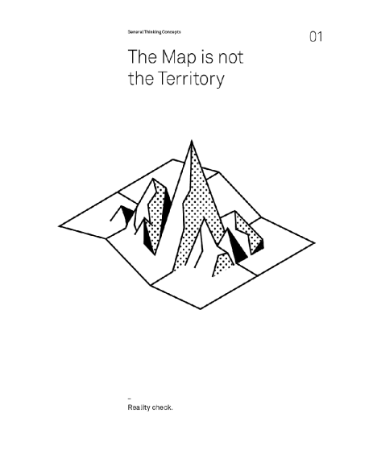
The map appears to us more real than the land.
D.H. Lawrence¹
The People Who Appear in this Chapter
Korzybski, Alfred.
1879-1950 - Polish-American independent scholar who developed the field of general semantics. He argued that knowledge is limited by our physical and language capabilities.
Newton, Sir Isaac.
1643-1727 - English polymath. One of the most influential scientists of all time. He related the workings of the Earth to the wonders of the universe. He also spent 27 years being Master of the Royal Mint.
Einstein, Albert.
1879-1955 - German theoretical physicist who gave us the theory of relativity and opened up the universe. He is famous for many things, including his genius, his kindness and his hair.
Ostrom, Elinor.
1933-2012 - American political economist. In 2009 she shared the Nobel Memorial Prize in Economic Sciences for her analysis of economic governance; in particular, questions related to “the commons”.
Abbud, Karimeh.
1893-1955 - Palestinian professional photographer. Also known as the “Lady Photographer”, she was an artist who lived and worked in Lebanon
and Palestine.
Jacobs, Jane.
1916-2006 - American-Canadian journalist, author, and activist who influenced urban studies, sociology, and economics. Her work has greatly impacted the development of North American cities.
The Map is not the Territory
The map of reality is not reality. Even the best maps are imperfect. That’s because they are reductions of what they represent. If a map were to represent the territory with perfect fidelity, it would no longer be a reduction and thus would no longer be useful to us. A map can also be a snapshot of a point in time, representing something that no longer exists. This is important to keep in mind as we think through problems and make better decisions.
We use maps every day. They help us navigate from one city to another. They help us reduce complexity to simplicity. Think of the financial statements for a company, which are meant to distill the complexity of thousands of transactions into something simpler. Or a policy document on office procedure, a manual on parenting a two-year-old, or your performance review. All are models or maps that simplify some complex territory in order to guide you through it.
Just because maps and models are flawed is not an excuse to ignore them. Maps are useful to the extent they are explanatory and predictive.
Key elements of a map
In 1931, the mathematician Alfred Korzybski presented a paper on mathematical semantics in New Orleans, Louisiana. Looking at it today, most of the paper reads like a complex, technical argument on the relationship of mathematics to human language, and of both to physical reality.
However, with this paper Korzybski introduced and popularized the concept that the map is not the territory. In other words, the description of the thing is not the thing itself. The model is not reality. The abstraction is not the abstracted.
Specifically, in his own words: ²
1. A map may have a structure similar or dissimilar to the structure of the territory. The London underground map is super useful to travelers. The train drivers don’t use it at all! Maps describe a territory in a useful way, but with a specific purpose. They cannot be everything to everyone.
2. Two similar structures have similar “logical” characteristics. If a correct map shows Dresden as between Paris and Warsaw, a similar relation is found in the actual territory. If you have a map showing where Dresden is, you should be able to use it to get there.
3. A map is not the actual territory. The London underground map does not convey what it’s like to be standing in Covent Garden station. Nor would you use it to navigate out of the station.
4. An ideal map would contain the map of the map, the map of the map of the map, etc., endlessly. We may call this characteristic self-reflexiveness. Imagine using an overly complicated “Guide to Paris” on a trip to France, and then having to purchase another book that was the “Guide to the Guide of Paris”. And so on. Ideally, you’d never have any issues—but eventually, the level of detail would be overwhelming.
The truth is, the only way we can navigate the complexity of reality is through some sort of abstraction. When we read the news, we’re consuming abstractions created by other people. The authors consumed vast amounts of information, reflected upon it, and drew some abstractions and conclusions that they share with us. But something is lost in the process. We can lose the specific and relevant details that were distilled into an abstraction. And, because we often consume these abstractions as gospel, without having done the hard mental work ourselves, it’s tricky to see when the map no longer agrees with the territory. We inadvertently forget that the map is not reality.
But my GPS didn’t show that cliff
We need maps and models as guides. But frequently, we don’t remember that our maps and models are abstractions and thus we fail to understand their limits. We forget there is a territory that exists separately from the map. This territory contains details the map doesn’t describe. We run into problems when our knowledge becomes of the map, rather than the actual underlying territory it describes.
When we mistake the map for reality, we start to think we have all the answers. We create static rules or policies that deal with the map but forget that we exist in a constantly changing world. When we close off or ignore feedback loops, we don’t see the terrain has changed and we dramatically reduce our ability to adapt to a changing environment. Reality is messy and complicated, so our tendency to simplify it is understandable. However, if the aim becomes simplification rather than understanding we start to make bad decisions.
We can’t use maps as dogma. Maps and models are not meant to live forever as static references. The world is dynamic. As territories change, our tools to navigate them must be flexible to handle a wide variety of situations or adapt to the changing times. If the value of a map or model is related to its ability to predict or explain, then it needs to represent reality. If reality has changed the map must change.
Take Newtonian physics. For hundreds of years it served as an extremely useful model for understanding the workings of our world. From gravity to celestial motion, Newtonian physics was a wide-ranging map.
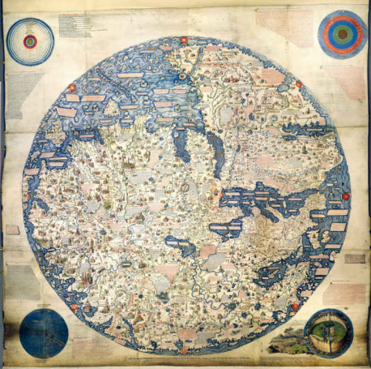
_
Would you be able to use this map to get to Egypt?
Then in 1905 Albert Einstein, with his theory of Special Relativity, changed our understanding of the universe in a huge way. He replaced the understanding handed down by Isaac Newton hundreds of years earlier. He created a new map.
Newtonian physics is still a very useful model. One can use it very
reliably to predict the movement of objects large and small, with some limitations as pointed out by Einstein. And, on the flip side, Einstein’s physics are still not totally complete: With every year that goes by, physicists become increasingly frustrated with their inability to tie it into small-scale quantum physics. Another map may yet come.
But what physicists do so well, and most of us do so poorly, is that they carefully delimit what Newtonian and Einsteinian physics are able to explain. They know down to many decimal places where those maps are useful guides to reality, and where they aren’t. And when they hit uncharted territory, like quantum mechanics, they explore it carefully instead of assuming the maps they have can explain it all.
Maps can’t show everything
Some of the biggest map/territory problems are the risks of the territory that are not shown on the map. When we’re following the map without looking around, we trip right over them. Any user of a map or model must realize that we do not understand a model, map, or reduction unless we understand and respect its limitations. If we don’t understand what the map does and doesn’t tell us, it can be useless or even dangerous.
— Sidebar: The Tragedy of the Commons
The Tragedy of the Commons
The Tragedy of the Commons is a parable that illustrates why common resources get used more than is desirable from the standpoint of society as a whole. Garrett Hardin wrote extensively about this concept.
“Picture a pasture open to all. It is to be expected that each herdsman will try to keep as many cattle as possible on the commons. Such an arrangement may work reasonably satisfactorily for centuries because tribal wars, poaching, and disease keep the numbers of both man and beast well below the carrying capacity of the land. Finally, however, comes the day of reckoning, that is, the day when the long desired goal of social stability becomes a reality. At this point, the inherent logic of the commons remorselessly generates tragedy.
As a rational being, each herdsman seeks to maximize his gain. Explicitly or implicitly, more or less consciously, he asks, “What is the utility to me of adding one more animal to my herd?” This utility has one negative and one positive component.
1. The positive component is a function of the increment of one animal. Since the herdsman receives all the proceeds from the sale of the additional animal, the positive utility is nearly +1.
2. The negative component is a function of the additional overgrazing created by one more animal. Since, however, the effects of overgrazing are shared by all the herdsmen, the negative utility for any particular decision-making herdsman is only a fraction of 1.
Adding together the component partial utilities, the rational herdsman concludes that the only sensible course for him to pursue is to add another animal to his herd. And another; and another. . . . But
this is the conclusion reached by each and every rational herdsman sharing a commons. Therein is the tragedy. Each man is locked into a system that compels him to increase his herd without limit—in a world that is limited. Ruin is the destination toward which all men rush, each pursuing his own best interest in a society that believes in the freedom
3
of the commons. Freedom in a commons brings ruin to all.”
What is common to many is taken least care of, for all men have greater regard for what is their own than for what they possess in common with others. –Aristotle
Here’s another way to think about it. Economist Elinor Ostrom wrote about being cautious with maps and models when looking at different governance structures for common resources. She was worried that the Tragedy of the Commons model (see sidebar), which shows how a shared resource can become destroyed through bad incentives, was too general and did not account for how people, in reality, solved the problem. She explained the limitations of using models to guide public policy, namely that they often become metaphors.
“What makes these models so dangerous … is that the constraints that are assumed to be fixed for the purpose of analysis are taken on 4
faith as being fixed in empirical setting.”
This is a double problem. First, having a general map, we may assume that if a territory matches the map in a couple of respects it matches the map in all respects. Second, we may think adherence to the map is more important than taking in new information about a territory. Ostrom asserts that one of the main values of using models as maps in public policy
discussions is in the thinking that is generated. They are tools for exploration, not doctrines to force conformity. They are guidebooks, not laws.
«Remember that all models are wrong; the practical question is how wrong do they have to be to not be useful.»
George Box
5
In order to use a map or model as accurately as possible, we should take three important considerations into account:
1. Reality is the ultimate update.
2. Consider the cartographer.
3. Maps can influence territories.
Reality is the ultimate update: When we enter new and unfamiliar territory it’s nice to have a map on hand. Everything from travelling to a new city, to becoming a parent for the first time has maps that we can use to improve our ability to navigate the terrain. But territories change, sometimes faster than the maps and models that describe them. We can and should update them based on our own experiences in the territory. That’s how good maps are built: feedback loops created by explorers.
We can think of stereotypes as maps. Sometimes they are useful— we have to process large amounts of information every day, and simplified chunks such as stereotypes can help us sort through this information with efficiency. The danger is when, like with all maps, we forget the territory is more complex. That people have far more territory than a stereotype can represent.
In the early 1900s, Europeans were snapping pictures all over
Palestine, leaving a record that may have reflected their ethnographic perspective, but did not cover Karimeh Abbud’s perception of her culture. She began to take photos of those around her, becoming the first female Arab to set up her own photo studio in Palestine. Her pictures reflected a different take on the territory—she rejected the European style and aimed to capture the middle class as they were. She tried to let her camera record the territory as she saw it versus manipulating the images to follow a narrative.
Her informal style and desire to photograph the variety around her, from landscapes to intimate portraits, have left a legacy far beyond the 6 , 7
photos themselves. She contributed a different perspective, a new map, with which to explore the history of the territory of Palestine. We do have to remember though, that a map captures a territory at a moment in time. Just because it might have done a good job at depicting what was, there is no guarantee that it depicts what is there now or what will be there in the future. The faster the rate of change in the territory, the harder it will be for a map to keep up to date.
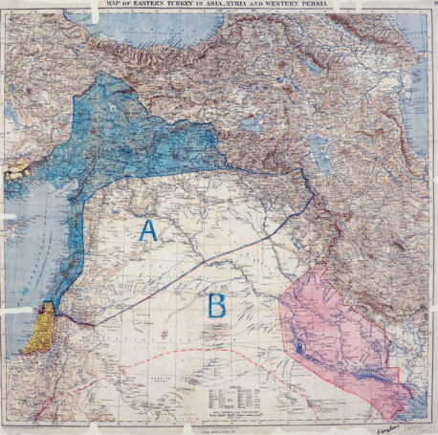
_
Dividing a large chunk of the Middle East into simply A and B, the Sykes Picot line proposed borders that paid little regard to ethnic or geographical features.
«Viewed in its development through time, the map details the changing thought of the human race, and
few works seem to be such an excellent indicator of culture and civilization.»
Norman J.W. Thrower 8
Consider the cartographer: Maps are not purely objective creations. They reflect the values, standards, and limitations of their creators. We can see this in the changing national boundaries that make up our world maps. Countries come and go depending on shifting political and cultural sensibilities. When we look at the world map we have today, we tend to associate societies with nations, assuming that the borders reflect a common identity shared by everyone contained within them.
However, as historian Margaret MacMillan has pointed out, nationalism is a very modern construct, and in some sense has developed 9
with, not in advance of, the maps that set out the shape of countries. We then should not assume that our literal maps depict an objective view of the geographical territory. For example, historians have shown that the modern borders of Syria, Jordan, and Iraq reflect British and French determination 10
to maintain influence in the Middle East after World War I. Thus, they are a better map of Western interest than of local custom and organization. Models, then, are most useful when we consider them in the context they were created. What was the cartographer trying to achieve? How does this influence what is depicted in the map?
« As a branch of human endeavor, cartography has a long and interesting history that well reflects the state of cultural activity, as well as the perception of the world, in different periods. … Though technical in
nature, cartography, like architecture, has attributes of both a scientific and artistic pursuit, a dichotomy not satisfactorily reconciled in all presentations. »
Norman J.W. Thrower
11
Maps can influence territories: This problem was part of the central argument put forth by Jane Jacobs in her groundbreaking work, The Death and Life of Great American Cities. She chronicled the efforts of city planners who came up with elaborate models for the design and organization of cities without paying any attention to how cities actually work. They then tried to fit the cities into the model. She describes how cities were changed to correspond to these models, and the often negative consequences of these efforts. “It became possible also to map out master plans for the statistical city, and people take these more seriously, for we are all accustomed to believe that maps and reality are necessarily related, or
12
that if they are not, we can make them so by altering reality.”
Jacobs’ book is, in part, a cautionary tale of what can happen when faith in the model influences the decisions we make in the territory. When we try to fit complexity into the simplification.
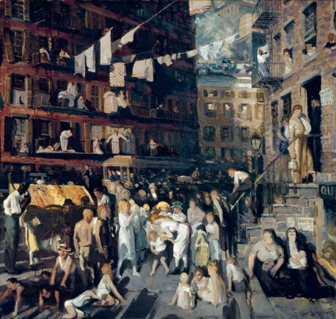
_
Jacobs demonstrated that mapping the interaction between people and sidewalks was an important factor in determining how to improve city safety.
«In general, when building statistical models, we must not forget that the aim is to understand
something about the real world. Or predict, choose an action, make a decision, summarize evidence, and so on, but always about the real world, not an abstract mathematical world: our models are not the reality. »
David Hand
13
Conclusion
Maps have long been a part of human society. They are valuable tools to pass on knowledge. Still, in using maps, abstractions, and models, we must always be wise to their limitations. They are, by definition, reductions of something far more complex. There is always at least an element of subjectivity, and we need to remember that they are created at particular moments in time.
This does not mean that we cannot use maps and models. We must use some model of the world in order to simplify it and therefore interact with it. We cannot explore every bit of territory for ourselves. We can use maps to guide us, but we must not let them prevent us from discovering new territory or updating our existing maps.
While navigating the world based on terrain is a useful goal, it’s not always possible. Maps, and models, help us understand and relate to the world around us. They are flawed but useful. In order to think a few steps ahead we must think beyond the map.
Model of Management
Let’s take a model of management. There are hundreds of them, dating back at least to the Scientific Theory of Management by Frederick Taylor, which had factory managers breaking down tasks into small pieces, forcing their workers to specialize, and financially incentivizing them to complete those tasks efficiently. It was a brute force method, but it worked pretty well.
As time went on and the economy increasingly moved away from manufacturing, other theories gained popularity, and Taylor’s scientific model is no longer used by anyone of note. That does not mean it wasn’t useful: For a time, it was. It’s just that reality is more complicated than Taylor’s model. It had to contend with at least the following factors:
1. As more and more people know what model you’re using to manipulate them, they may decide not to respond to your incentives.
2. As your competitors gain knowledge of the model, they respond in kind by adopting the model themselves, thus flattening the field.
3. The model may have been mostly useful in a factory setting, and not in an office setting, or a technology setting.
4. Human beings are not simple automatons: A more complete model would hone in on other motivations they might have besides financial ones.
And so on. Clearly, though Taylor’s model was effective for a time, it was effective with limitations. As with Einstein eclipsing Newton, better models came along in time.
Maps Are Necessarily Flawed
Maps, or models, are necessary but necessarily flawed. Lewis Carroll once jabbed at this in a story called Sylvie and Bruno, where one of the characters decided that his country would create a map with the scale of one mile to one mile. Obviously, such a map would not have the limitations of a map, but it wouldn’t be of much help either. You couldn’t use it to actually go anywhere. It wouldn’t fit in your pocket or your car. We need maps to condense the territory we are trying to navigate.

_
Illustration from the first edition of Sylvie and Bruno, published in 1889
I’m no genius. I’m smart in spots— but I stay around those spots. Thomas Watson¹
The People Who Appear in this Chapter
Norgay, Tenzing, born Namgyal Wangdi.
1914-1986 - Nepali Sherpa mountaineer. Time named him one of the 100 most influential people of the 20th century.
Gawande, Atul.
1965 - American surgeon, writer, and public health researcher. He practices medicine in Boston, is a professor at Harvard University, and has been a staff writer for The New Yorker since 1998.
Elizabeth I.
1533-1603 - Queen of England and Ireland. One of the most famous monarchs of all time, her image and legacy continue to capture the imagination. Elizabeth was a great orator, could speak about 11 languages, and wrote her own speeches and letters.
Circle of Competence
When ego and not competence drives what we undertake, we have blind spots. If you know what you understand, you know where you have an edge over others. When you are honest about where your knowledge is lacking you know where you are vulnerable and where you can improve. Understanding your circle of competence improves decision-making and outcomes.
In order to get the most out of this mental model, we will explore the following:
1. What is a circle of competence?
2. How do you know when you have one?
3. How do you build and maintain one?
4. How do you operate outside of one?
What is a circle of competence? Imagine an old man who’s spent his entire life up in a small town. He’s the Lifer. No detail of the goings-on in the town has escaped his notice over the years. He knows the lineage, behavior, attitudes, jobs, income, and social status of every person in town. Bit by bit, he built that knowledge up over a long period of observation and participation in town affairs.
The Lifer knows where the bodies are buried and who buried them. He knows who owes money to whom, who gets along with whom, and who the town depends on to keep spinning. He knows about that time the mayor cheated on his taxes. He knows about that time the town flooded, how many inches high the water was, and exactly who helped whom and who didn’t.
Now imagine a Stranger enters the town, in from the Big City. Within a few days, the Stranger decides that he knows all there is to know about the town. He’s met the mayor, the sheriff, the bartender, and the shopkeeper, and he can get around fairly easily. It’s a small town and he
hasn’t come across anything surprising.
In the Stranger’s mind, he’s convinced he pretty much knows everything a Lifer would know. He has sized up the town in no time, with his keen eye. He makes assumptions based on what he has learned so far, and figures he knows enough to get his business done. This, however, is a false sense of confidence that likely causes him to take more risks than he realizes. Without intimately knowing the history of the town, how can he be sure that he has picked the right land for development, or negotiated the best price?
After all, what kind of knowledge does he really have, compared to the Lifer?
The difference between the detailed web of knowledge in the Lifer’s head and the surface knowledge in the Stranger’s head is the difference between being inside a circle of competence and being outside the perimeter. True knowledge of a complex territory cannot be faked. The Lifer could stump the Stranger in no time, but not the other way around. Consequently, as long as the Lifer is operating in his circle of competence he will always have a better understanding of reality to use in making decisions. Having this deep knowledge gives him flexibility in responding to challenges, because he will likely have more than one solution to every problem. And this depth increases his efficiency—he can eliminate bad choices quickly because he has all the pieces of the puzzle.
What happens when you take the Lifer/Stranger idea seriously and try to delineate carefully the domains in which you’re one or the other? There is no definite checklist for figuring this out, but if you don’t have at least a few years and a few failures under your belt, you cannot consider yourself competent in a circle.
«We shall be unable to turn natural advantage to account unless we make use of local guides.»
Sun Tzu
2
For most of us, climbing to the summit of Mount Everest is outside our circles of competence. Not only do we have no real idea how to do it, but— even more scary—should we attempt it, we don’t even know what we don’t know. If we studied hard, maybe we’d figure out the basics. We’d learn about the training, the gear, the process, the time of year, all the things an outsider could quickly know. But at what point would you be satisfied that you knew enough to get up there, and back, with your life intact? And how confident would you be in this assessment?
There are approximately 200 bodies on Everest (not to mention the ones that have been removed). All of those people thought they could get up and down alive. The climate preserves their corpses, almost as a warning. The ascent to the summit takes you by the bodies of people who once shared your dreams.
Since the first recorded attempts to climb Everest in 1922, all climbers have relied on the specialized knowledge of the Sherpa people to help navigate the terrain of the mountain. Indigenous to the region, Sherpas grew up in the shadows of the mountain, uniquely placed to develop the circle of competence necessary to get to the top.
3
Sherpa Tenzing Norgay led the team that made the first ascent , and a quarter of all subsequent ascents have been made by Sherpas (some going 4 , 5
as many as 16 times). Although the mountain is equally risky for everyone, most people who climb Everest do it once. For the Sherpas, working and climbing various parts of the mountain is their day job. Would you try to climb Everest without their help?
_
Sherpa Tenzing Norgay and his ilk are the real lifers. Yet strangers often ignore their advice much to their peril.
The physical challenges alone of reaching the summit are staggering. It is a region that humans aren’t suited for. There isn’t enough oxygen in the air and the top is regularly pummeled by winds of more than 150 miles an hour—stronger than a Category 5 hurricane. You don’t get to the top on a whim, and you don’t survive with only luck. Norgay worked for years as a trekking porter, and was part of a team that tried to ascend Everest in 1935. He finally succeeded in reaching the summit in 1953, after 20 years of climbing and trekking in the region. He developed his expertise through lots of lucky failures. After Everest, Norgay opened a mountaineering school to train other locals as guides, and a trekking company to take others climbing in the Himalayas.
Norgay is around the closest someone could come to being a Lifer when it comes to the competence required to climb Mount Everest.
How do you know when you have a circle of competence? Within our circles of competence, we know exactly what we don’t know. We are able to make decisions quickly and relatively accurately. We possess detailed knowledge of additional information we might need to make a decision with full understanding, or even what information is unobtainable. We know what is knowable and what is unknowable and can distinguish between the two.
We can anticipate and respond to objections because we’ve heard them before and already put in the work of gaining the knowledge to counter them. We also have a lot of options when we confront problems in our circles. Our deep fluency in subjects we are dealing with means we can draw on different information resources and understand what can be adjusted and what is invariant.
A circle of competence cannot be built quickly. We don’t become Lifers overnight. It isn’t the result of taking a few courses or working at something for a few months—being a Lifer requires more than skimming the surface. In Alexander Pope’s poem “An Essay on Criticism,” he writes:
“A little learning is a dangerous thing;
Drink deep, or taste not the Pierian spring:
There shallow draughts intoxicate the brain,
6
And drinking largely sobers us again.”
There is no shortcut to understanding. Building a circle of competence takes years of experience, of making mistakes, and of actively seeking out better methods of practice and thought.
How do you build and maintain a circle of competence?
One of the essential requirements of a circle of competence is that you can never take it for granted. You can’t operate as if a circle of competence is a static thing, that once attained is attained for life. The world is dynamic. Knowledge gets updated, and so too must your circle.
There are three key practices needed in order to build and maintain a circle of competence: curiosity and a desire to learn, monitoring, and feedback.
First, you have to be willing to learn. Learning comes when experience meets reflection. You can learn from your own experiences. Or you can learn from the experience of others, through books, articles, and conversations. Learning everything on your own is costly and slow. You are one person. Learning from the experiences of others is much more productive. You need to always approach your circle with curiosity, seeking out information that can help you expand and strengthen it.
«Learn from the mistakes of others. You can’t live long enough to make them all yourself.» Anonymous
Second, you need to monitor your track record in areas which you have, or
want to have, a circle of competence. And you need to have the courage to monitor honestly so the feedback can be used to your advantage. The reason we have such difficulty with overconfidence—as demonstrated in studies which show that most of us are much worse drivers, lovers, managers, traders (and many other things) than we think we are—is because we have a problem with honest self-reporting. We don’t keep the right records, because we don’t really want to know what we’re good and bad at. Ego is a powerful enemy when it comes to better understanding reality.
But that won’t work if you’re trying to assess or build your circle of competence. You need to keep a precise diary of your trades, if you’re investing in the stock market. If you are in a leadership position, you need to observe and chronicle the results of your decisions and evaluate them based on what you were trying to achieve. You need to be honest about your failures in order to reflect and learn from them. That’s what it takes.
Keeping a journal of your own performance is the easiest and most private way to give self-feedback. Journals allow you to step out of your automatic thinking and ask yourself: What went wrong? How could I do better? Monitoring your own performance allows you to see patterns that you simply couldn’t see before. This type of analysis is painful for the ego, which is also why it helps build a circle of competence. You can’t improve if you don’t know what you’re doing wrong.
Finally, you must occasionally solicit external feedback. This helps build a circle, but is also critical for maintaining one.
A lot of professionals have an ego problem: their view of themselves does not line up with the way other people see them. Before people can change they need to know these outside views. We need to go to people we trust, who can give us honest feedback about our traits. These people are in a position to observe us operating within our circles, and are thus able to offer relevant perspectives on our competence. Another option is to hire a
coach.
Atul Gawande is one of the top surgeons in the United States. And when he wanted to get better at being a surgeon, he hired a coach. This is terribly difficult for anyone, let alone a doctor. At first he felt embarrassed. It had been over a decade since he was evaluated by another person in medical school. “Why,” he asked, “should I expose myself to the scrutiny
and fault-finding?”
7
The coach worked. Gawande got two things out of this. First, Gawande received something he couldn’t see himself and something no one else would point out (if they noticed it at all): knowledge of where his skill and technique was suboptimal. The second thing Gawande took away was the ability to provide better feedback to other doctors.
It is extremely difficult to maintain a circle of competence without an outside perspective. We usually have too many biases to solely rely on our own observations. It takes courage to solicit external feedback, so if defensiveness starts to manifest, focus on the result you hope to achieve.
How do you operate outside a circle of competence?
Part of successfully using circles of competence includes knowing when we are outside them—when we are not well equipped to make decisions. Since we can’t be inside a circle of competence in everything, when we find ourselves Strangers in a place filled with Lifers, what do we do? We don’t always get to “stay around our spots.” We must develop a repertoire of techniques for managing when we’re outside of our sphere, which happens
all the time.
8
There are three parts to successfully operating outside a circle of competence:
1. Learn at least the basics of the realm you’re operating in, while acknowledging that you’re a Stranger, not a Lifer. However, keep in
mind that basic information is easy to obtain and often gives the acquirer an unwarranted confidence.
2. Talk to someone whose circle of competence in the area is strong. Take the time to do a bit of research to at least define questions you need to ask, and what information you need, to make a good decision. If you ask a person to answer the question for you, they’ll be giving you a fish. If you ask them detailed and thoughtful questions, you’ll learn how to fish. Furthermore, when you need the advice of others, especially in higher stakes situations, ask questions to probe the limits of their circles. Then ask yourself how the situation might influence the information they choose to provide you.
3. Use a broad understanding of the basic mental models of the world to augment your limited understanding of the field in which you find yourself a Stranger. These will help you identify the foundational concepts that would be most useful. These then serve as a guide to help you navigate the situation you are in.
There are inevitably areas where you are going to be a Stranger, even in the profession in which you excel. It is impossible for our circles of competence to encompass the entire world. Even if we’re careful to know the boundaries and take them seriously, we can’t always operate inside our circles. Life is simply not that forgiving. We have to make HR decisions without being experts in human psychology, implement technology without having the faintest idea how to fix it if something goes wrong, or design products with an imperfect understanding of our customers. These decisions may be outside our circles, but they still have to get made.
The Problem of Incentives
The problem of incentives can really skew how much you can rely on someone else’s circle of competence. This is particularly acute in the financial realm. Until recently, nearly all financial products we might be pushed into had commissions attached to them—in other words, our advisor made more money by giving us one set of advice than another, regardless of its wisdom. Fortunately, the rise of things like index funds of the stock and bond markets has mostly alleviated the issue.
In cases like financial advisory, we’re not on solid ground until we know, in some detail, the compensation arrangement our advisor is under.
The same goes for buying furniture, buying a house, or buying a washing machine at a retail store. What does the knowledgeable advisor stand to gain from our purchase?
It goes beyond sales, of course. Whenever we are getting advice, it is from a person whose set of incentives is not the same as ours. It is not being cynical to know that this is the case, and to then act accordingly.
Suppose we want to take our car to a mechanic. Most of us, especially in this day and age, are complete Strangers in that land; we subsequently are open to be taken advantage of. There is not only an asymmetry in our general knowledge base about mechanics of a car, there is usually an asymmetry of knowledge about the actual current problem with the car. We haven’t been under the hood, but the mechanic has. We know his incentive in this situation; it’s to get us to spend as much as possible while still retaining us as a customer. The
only solution, at least until we reach a certain level of trust with our mechanic, is to suck it up and learn a bit of the trade.
Fortunately, these days that is easy with the aid of the internet. And we don’t need to learn it ahead of time. We can learn it on an as needed basis. The way to do it, in this case, would be to defer all decisions on major spending until you’ve had time to poke around the resources you can find online and at least confirm that the mechanic isn’t making a major bluff.
_
You can’t see what’s wrong but trust me.

